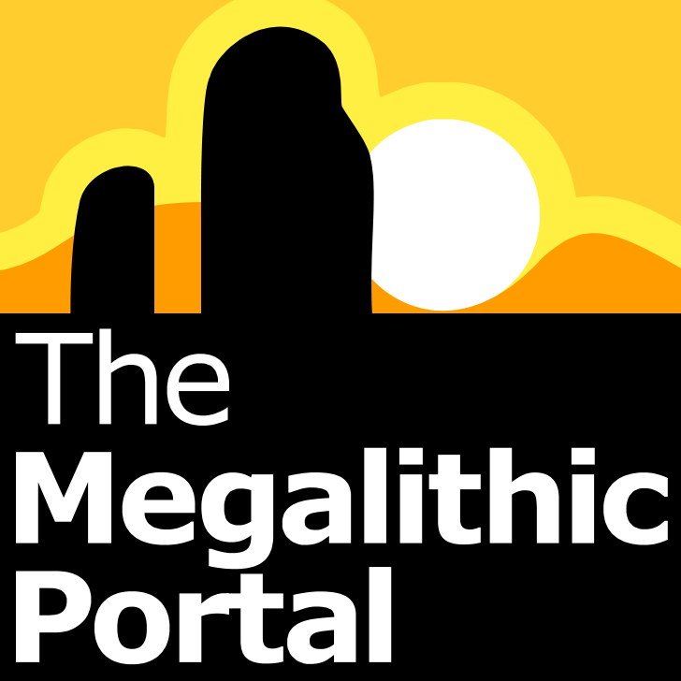

Andy Burnham
andy@megalithic.co.uk
07758 329598

megalithic.co.uk
The top destination for prehistoric & ancient sites

Maps * Worldwide Database News * Social Networking

